11. Develop a system using UML for Conference Management System. It should manage the details of the process that will be taking place at the conference. It should work along with the organizer, who arranges the program and central management system, which consists of all the details of the member and the role he/she, who is going to participate in the presentation

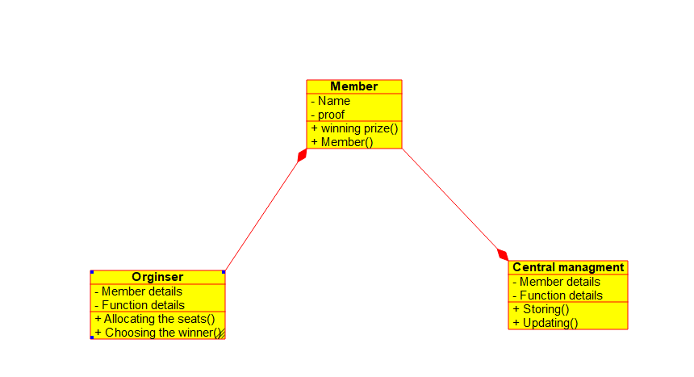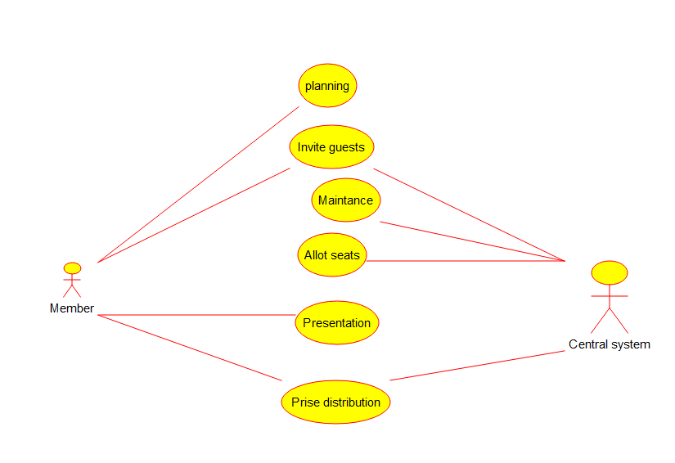

12. Develop a system using UML for Foreign Trading System, to maintain the details about the trading system that exists between the two countries. These details are to be held by the trading management system. The supplier and the customer will interact with the system

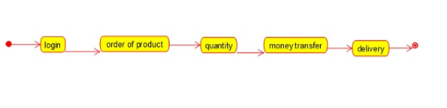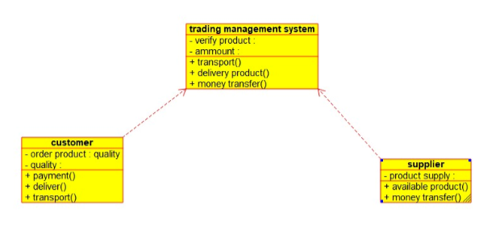

13. Develop a system using UML for BPO Management System. The system should hold the details of the customer and all approaches to it. It is managed by the central system.

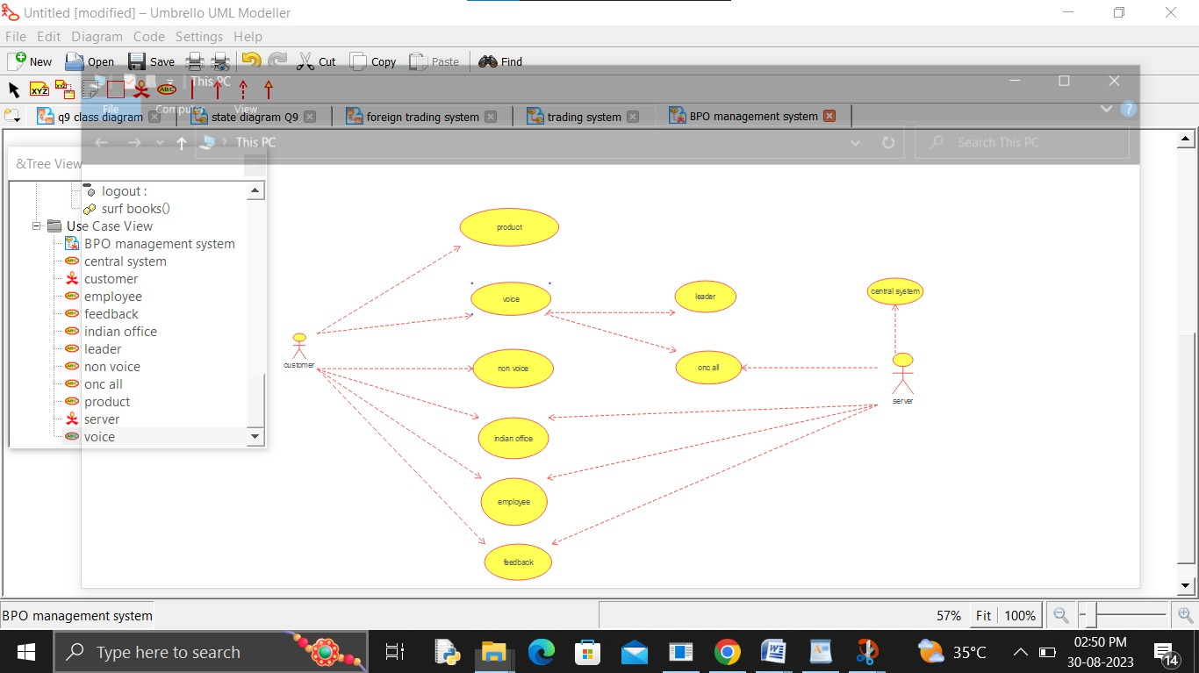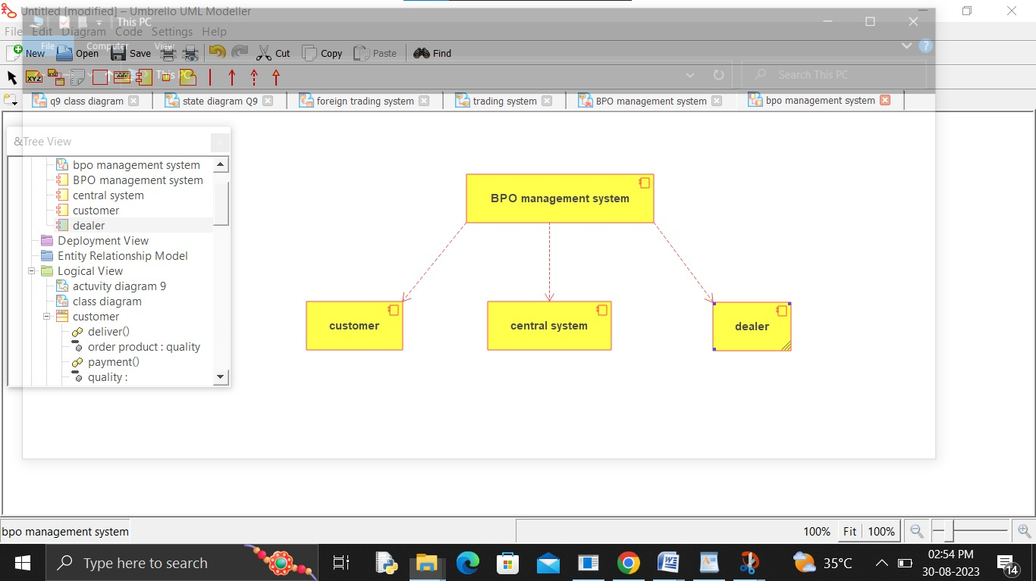

14.Develop a system using UML for E-Commerce Registration System, to add customers. Then a catalog should be produced for the customer to add items to the cart. The return system should be included, to allow customers to return items within a specific time.

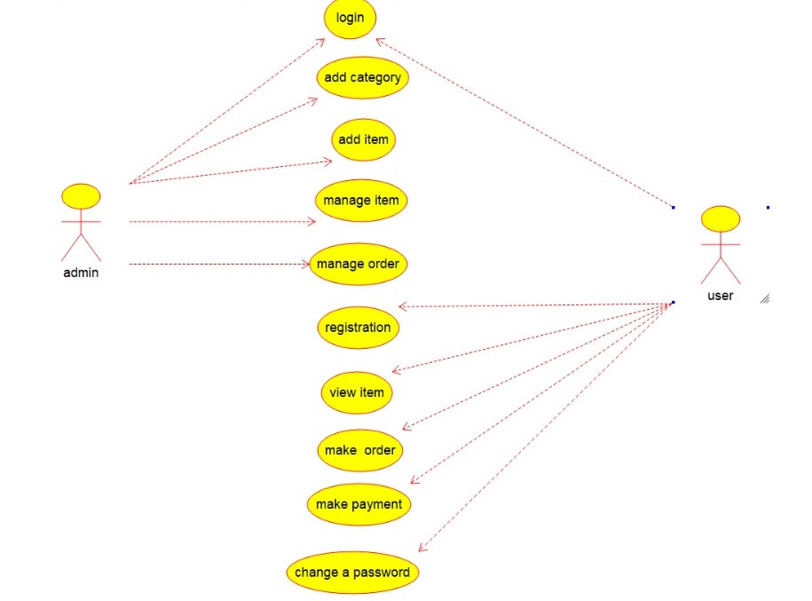

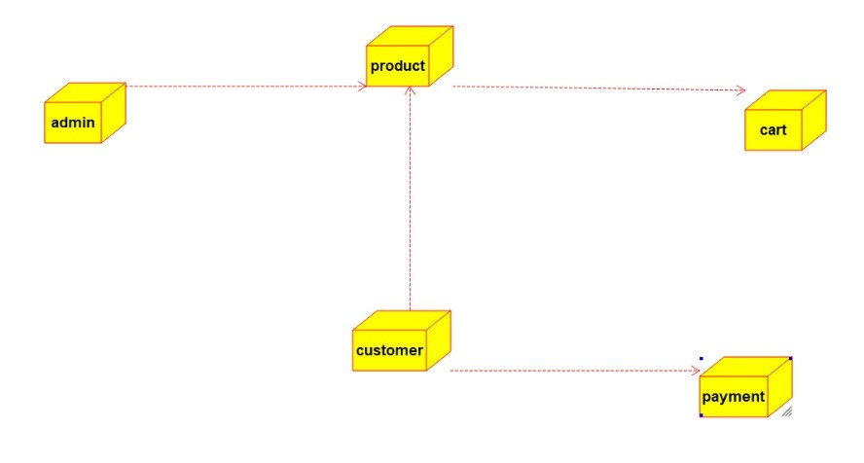

15.Develop a system using UML for Blood Bank Registration System. The system should have the list of donors and the hospitals can check for the donor's availability and get their appointment. The donor and the hospital can interact with the central system

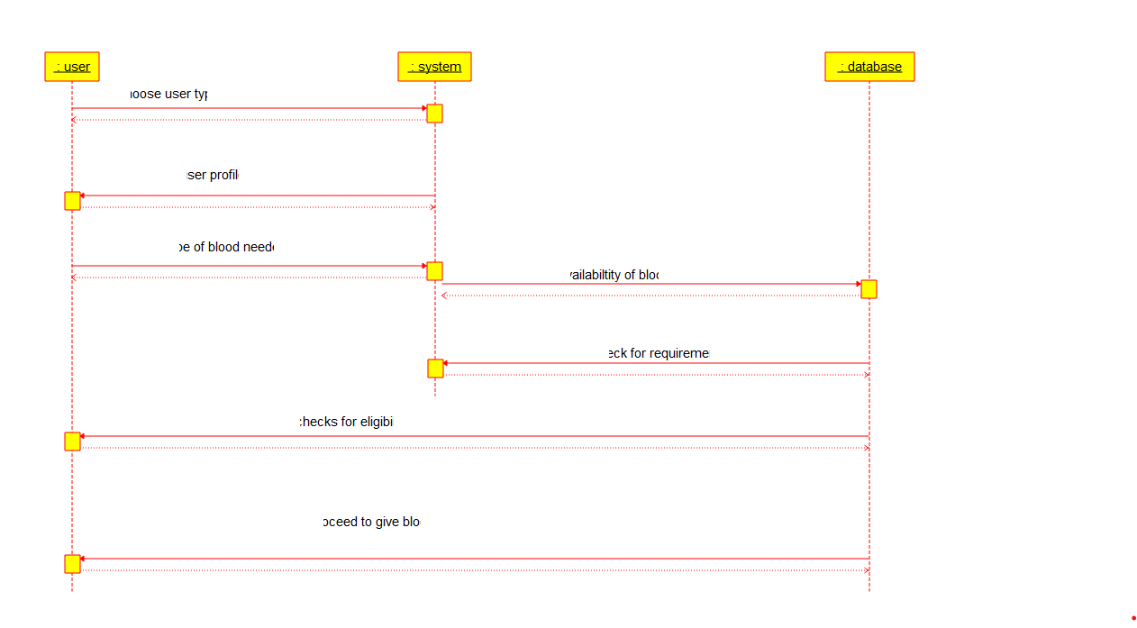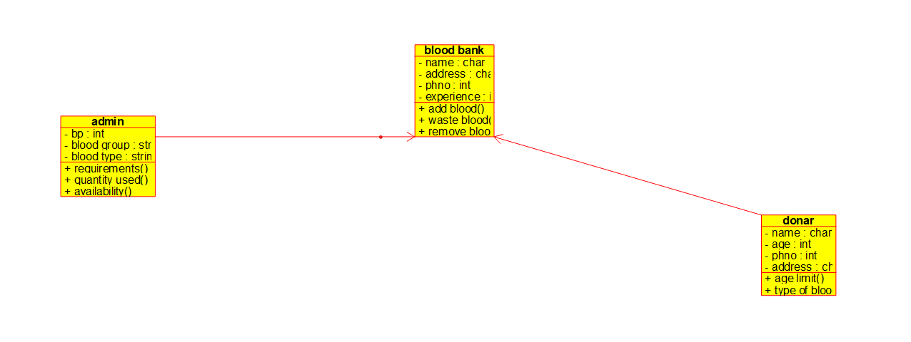

16. Develop a system using UML for Online Internship Registration System. It should verify the details of the candidate by the central computer. The details regarding the candidate will be provided to the central computer through the administrator and the computer will verify the details of the

Candidate and provide approval. Then the internship letter will be issued from the company to the candidate.

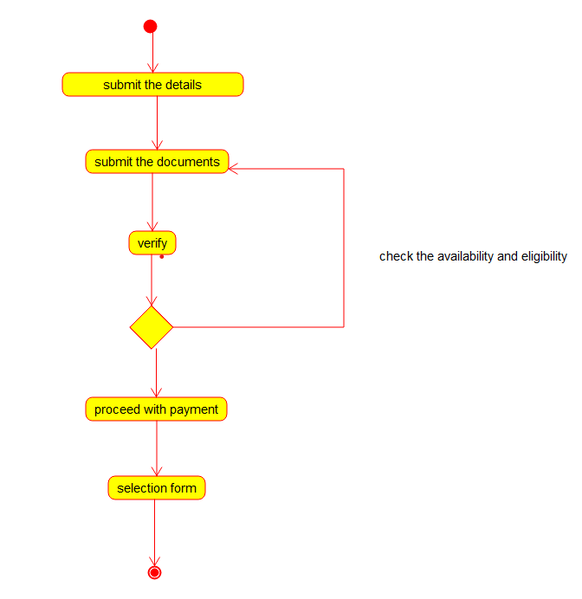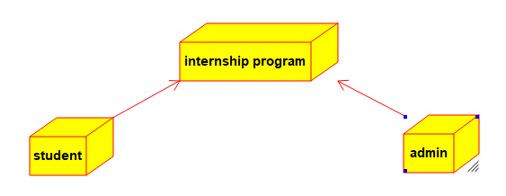

17. Develop a system using UML for Vehicle Registration Number Registering System. The owner should apply with the documents and pay the fee, once the documents had been accepted and the vehicle is verified. Then the document for registration is issued by the system.

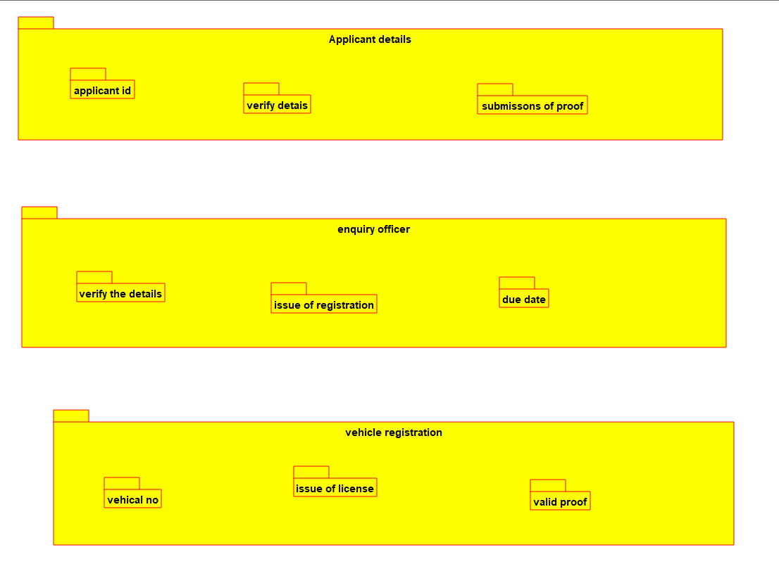

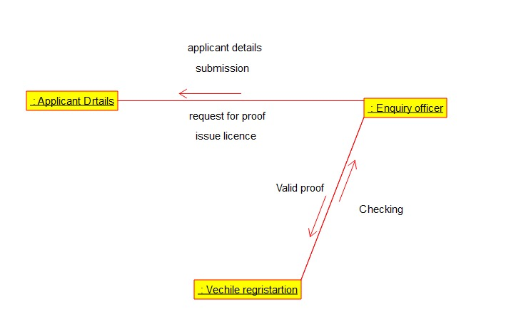

18.Develop a system using UML for Food Order System. In this system, the customer can place orders and purchase items with the aid of the dealer and central food system. These orders are verified and the items are delivered to the customer.

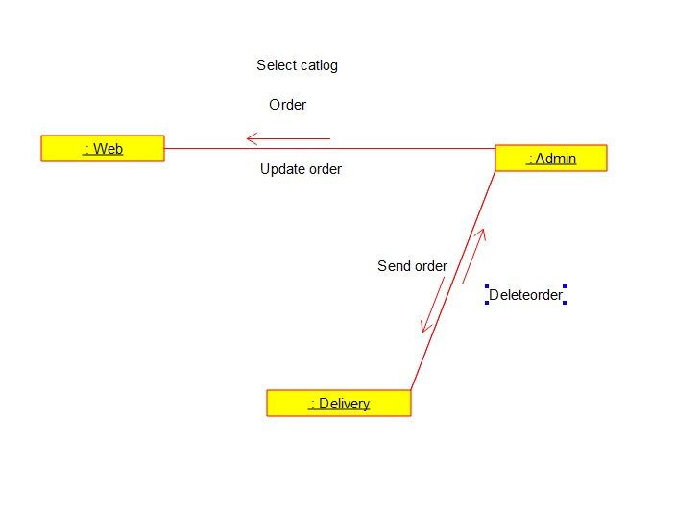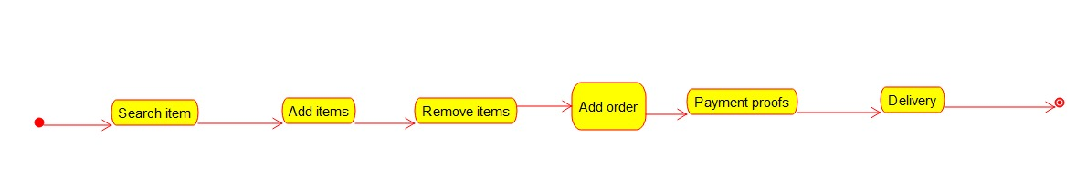

19.Develop a system using UML for Home Services System. HACS is a system controlled by a remote system such as a mobile phone and coordinates home appliances. The document furnishes the detailed design with all the UML diagrams. It encompasses CRC cards, Use Case Diagrams, Sequence Diagrams, and Class Diagrams for home appliance control systems (HACS).

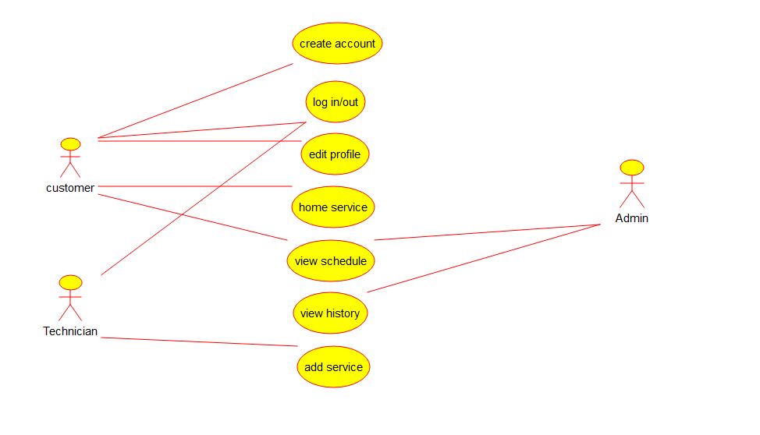

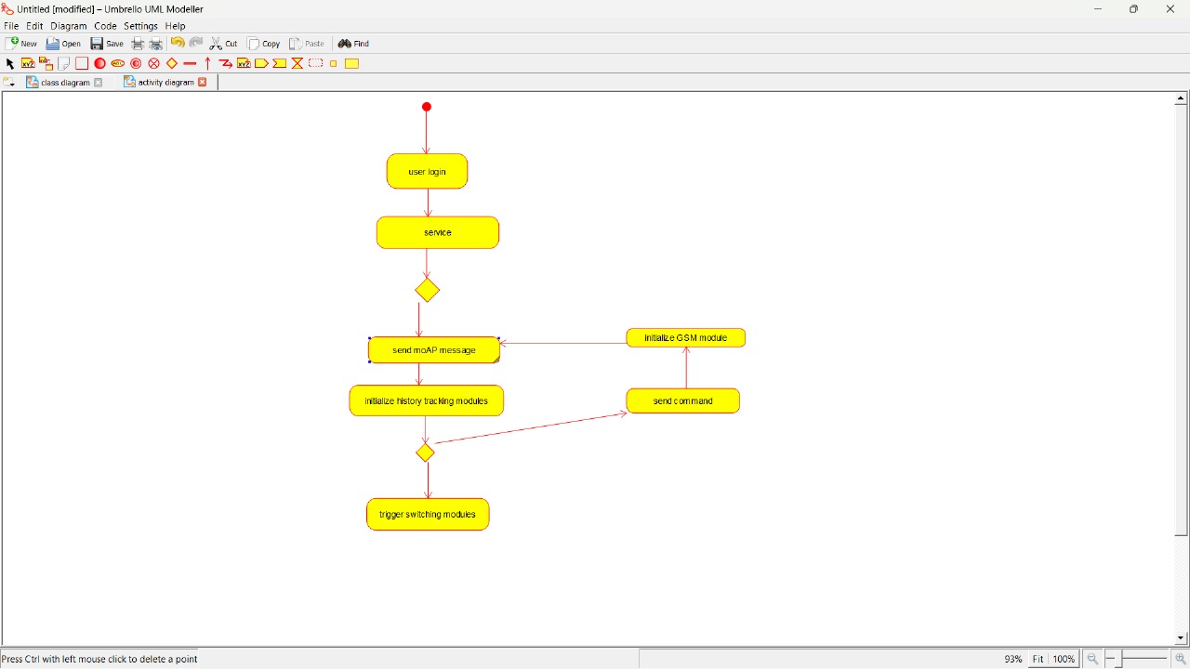

20 Develop a system using UML for Library Management System. It should verify the details of the reader by the central computer. The details regarding the reader will be provided to the central computer through the administrator in the library and the computer will verify the details of the reader and provide approval to the office. Then the books that are needed by the reader will issue from the library to him

